OCEANA COUNTY

**4-H SMALL MARKET**

**CHICKEN RECORD BOOK – 2024**

**(for ages 8 and up)**

**AN03356_**

As a member of the Small Market Animal Project, you are required to submit your records as part of an educational project notebook in order to show your animal at the Oceana County Fair. **This notebook must be shown to the Poultry Superintendent or designated Small Market Weighmaster at the time of weigh-in and then entered by you in the Educational Notebook Division at the Oceana County Fair on Entry Day.**

**AGE: \_\_\_\_\_\_\_\_\_\_**

The age you enter depends on how old you were on January 1, 2024.

**NUMBER OF YEARS IN PROJECT: \_\_\_\_\_\_\_\_\_\_**

Use this sheet as the first page of your project record book. Fill it out completely.

**Please print or type neatly**.

# NAME \_\_\_\_\_\_\_\_\_\_\_\_\_\_\_\_\_\_\_\_\_\_\_\_\_\_\_\_\_\_\_\_\_\_\_\_\_\_\_\_\_\_\_\_\_\_\_\_\_\_\_\_\_\_\_\_\_\_\_\_\_\_\_\_\_\_\_

# 4-H CLUB \_\_\_\_\_\_\_\_\_\_\_\_\_\_\_\_\_\_\_\_\_\_\_\_\_\_\_\_\_\_\_\_\_\_\_\_\_\_\_\_\_\_\_\_\_\_\_\_\_\_\_\_\_\_\_\_\_\_\_\_\_\_

**LEADER \_\_\_\_\_\_\_\_\_\_\_\_\_\_\_\_\_\_\_\_\_\_\_\_\_\_\_\_\_\_\_\_\_\_\_\_\_\_\_\_\_\_\_\_\_\_\_\_\_\_\_\_\_\_\_\_\_\_\_\_\_\_\_\_\_\_**

# DATE RECORDS STARTED \_\_\_\_\_\_\_\_\_\_\_\_\_\_\_\_\_\_ DATE ENDED \_\_\_\_\_\_\_\_\_\_\_\_\_\_\_\_\_

**CHICKEN BREED VARIETY \_\_\_\_\_\_\_\_\_\_\_\_\_\_\_\_\_\_\_\_\_\_\_\_\_\_\_\_\_\_\_\_\_\_\_\_\_\_\_\_\_\_\_\_\_\_\_\_\_**

****

**JUDGE’S SCORE/COMMENT SHEET**

**(PLEASE DO NOT REMOVE, PLACE THIS SHEET IN SHEET PROTECTOR OR GLUE TO COVER). This sheet must be keep free to the judge to write their comments.**

This sheet should help each 4-H’er understand their ribbon placing.

A. **Specific educational value or worth**

\_\_\_ All questions were answered completely

\_\_\_ All calculations were correct

\_\_\_ Calculations were incorrect

\_\_\_ Questions were not completely answered

\_\_\_ Questions were not answered (missed questions)

B. **Notebook contains all project records**

\_\_\_ Notebook contained all project records and were fully completed

\_\_\_ Notebook contained additional project related information (research

materials etc.)

\_\_\_ Project records were incomplete

\_\_\_There was no additional project related information

C. **Accuracy, neatness and general appearance**

\_\_\_Notebook was neat in appearance (typed/hand printed)

\_\_\_ Notebook pages were clean and stain free

\_\_\_Notebook pages were in order and complete

\_\_\_Notebook pages were out of order and missing pages

\_\_\_Notebook was difficult to read and messy

\_\_\_Notebook had wrinkled and stained pages

Other Comments: \_\_\_\_\_\_\_\_\_\_\_\_\_\_\_\_\_\_\_\_\_\_\_\_\_\_\_\_\_\_\_\_\_\_\_\_\_\_\_\_\_\_\_\_\_\_\_\_\_\_\_\_\_\_\_\_\_\_\_\_\_\_\_\_\_\_\_\_\_\_\_\_\_\_\_\_\_\_\_\_\_\_\_\_\_\_\_\_\_\_

\_\_\_\_\_\_\_\_\_\_\_\_\_\_\_\_\_\_\_\_\_\_\_\_\_\_\_\_\_\_\_\_\_\_\_\_\_\_\_\_\_\_\_\_\_\_\_\_\_\_\_\_\_\_\_\_\_\_\_\_\_\_\_\_\_\_\_\_\_\_\_\_\_\_\_\_\_\_\_\_\_\_\_\_\_\_\_\_\_\_

\_\_\_\_\_\_\_\_\_\_\_\_\_\_\_\_\_\_\_\_\_\_\_\_\_\_\_\_\_\_\_\_\_\_\_\_\_\_\_\_\_\_\_\_\_\_\_\_\_\_\_\_\_\_\_\_\_\_\_\_\_\_\_\_\_\_\_\_\_\_\_\_\_\_\_\_\_\_\_\_\_\_\_\_\_\_\_\_\_\_

2024- SMA CHICKENS PAGE 2

## OBJECTIVES

1. Develop desirable work habits, sportsmanship, and ability to cooperate and express ideas through participation in projects, discussions, method demonstrations, judging teams, and exhibits.
2. Experience the pride and responsibility of leasing/owning and caring for poultry.
3. Learn how to feed, fit, show, breed and raise poultry.
4. Learn proper handling procedures to prevent injuries to 4-H members and their poultry projects.
5. Appreciate and use scientific information in poultry production and marketing.
6. Improve knowledge of grading, marketing and merchandising of poultry and poultry products.
7. Improve knowledge of the nutritive value of poultry meat and eggs and how they contribute toward good health.
8. Learn the importance of the poultry industry to the local, state, and national economies.
9. Acquire information on the opportunity that poultry offers as a career.

This record book is part of your Small Market Chicken project. By keeping records up-to-date you will be able to see how much progress you make as you set goals and work to accomplish them. Write or type neatly and clearly. Please keep the pages in order. Feel free to add extra pages at the end of your notebook.

SCORING CRITERIA

The following breakdown will be used during the judging process of all market livestock notebooks.

A. Specific educational value or worth **30%**

B. Creative way of showing what has been learned **10%**

C. Notebooks contains all project records **50%**

D. Accuracy, neatness and general appearance **10%**

2024- SMA CHICKENS PAGE 3

**JOURNAL OF CARE**

The SMAA Committee would like the judge to see the time and effort which you put into the care & management of your project.

Include the following:

* Feeding and watering practices
* Health practices and medicines (vaccinations, etc.)
* General Management (building a cage, cleaning living area, feed pans, etc.)

|  |
| --- |
| **DAILY- Things done once or twice a day** |
|  |
| **WEEKLY- Things done once or twice a week** |
|  |
| **MONTHLY- Things done once a month** |
|  |
| **YEARLY- Things done one time or occasionally throughout the year** |
|  |

2024- SMA CHICKENS PAGE 4

**Describe the type of chickens being used in this project. List breed and variety. Why did you choose this breed?**

\_\_\_\_\_\_\_\_\_\_\_\_\_\_\_\_\_\_\_\_\_\_\_\_\_\_\_\_\_\_\_\_\_\_\_\_\_\_\_\_\_\_\_\_\_\_\_\_\_\_\_\_\_\_\_\_\_\_\_\_\_\_\_\_\_\_\_\_\_\_\_\_\_\_\_\_\_\_

\_\_\_\_\_\_\_\_\_\_\_\_\_\_\_\_\_\_\_\_\_\_\_\_\_\_\_\_\_\_\_\_\_\_\_\_\_\_\_\_\_\_\_\_\_\_\_\_\_\_\_\_\_\_\_\_\_\_\_\_\_\_\_\_\_\_\_\_\_\_\_\_\_\_\_\_\_\_

\_\_\_\_\_\_\_\_\_\_\_\_\_\_\_\_\_\_\_\_\_\_\_\_\_\_\_\_\_\_\_\_\_\_\_\_\_\_\_\_\_\_\_\_\_\_\_\_\_\_\_\_\_\_\_\_\_\_\_\_\_\_\_\_\_\_\_\_\_\_\_\_\_\_\_\_\_\_

\_\_\_\_\_\_\_\_\_\_\_\_\_\_\_\_\_\_\_\_\_\_\_\_\_\_\_\_\_\_\_\_\_\_\_\_\_\_\_\_\_\_\_\_\_\_\_\_\_\_\_\_\_\_\_\_\_\_\_\_\_\_\_\_\_\_\_\_\_\_\_\_\_\_\_\_\_\_

\_\_\_\_\_\_\_\_\_\_\_\_\_\_\_\_\_\_\_\_\_\_\_\_\_\_\_\_\_\_\_\_\_\_\_\_\_\_\_\_\_\_\_\_\_\_\_\_\_\_\_\_\_\_\_\_\_\_\_\_\_\_\_\_\_\_\_\_\_\_\_\_\_\_\_\_\_\_

## WEIGHT CHART

|  |  |  |
| --- | --- | --- |
| Date | Age | **Weight** |
|  |  |  |
|  |  |  |
|  |  |  |
|  |  |  |
|  |  |  |
|  |  |  |

**FINAL WEIGHT (FW)\_\_\_\_\_\_\_\_\_\_\_ AGE\_\_\_\_\_\_\_\_\_\_ DATE\_\_\_\_\_\_\_\_\_\_\_**

2024- SMA CHICKENS PAGE 5

## EXPENSES

##### (A) Cost of chicks $\_\_\_\_\_\_\_\_\_\_\_\_\_\_\_\_\_\_\_\_\_\_\_

|  |  |  |  |
| --- | --- | --- | --- |
| **DATE** | LBS. OF FEED | FEED VARIETY | COST |
|  |  |  | **$** |
|  |  |  |  |
|  |  |  |  |
|  |  |  |  |
| **(B)** |  | **TOTAL SPENT ON FEED** | **$** |

|  |  |  |
| --- | --- | --- |
| **DATE** | OTHER EXPENSES, VET, SUPPLIES, HOUSING, ETC. | COST |
|  |  | **$** |
|  |  |  |
|  |  |  |
|  |  |  |
| **(C)** | **TOTAL SPENT ON OTHER EXPENSES** | **$** |

##### GRAND TOTAL OF ALL EXPENSES (TE): $ \_\_\_\_\_\_\_\_\_\_\_\_\_\_\_\_\_\_\_\_\_\_\_

**(total of A+B+C)**

**\_\_\_\_\_\_\_\_\_\_\_\_\_\_\_ ÷ \_\_\_\_\_\_\_\_\_\_\_\_\_\_\_\_\_ = \_\_\_\_\_\_\_\_\_\_\_\_\_\_\_\_\_\_\_\_\_\_\_\_\_\_\_\_\_\_\_\_\_\_\_\_\_\_**

Total Expenses **(TE)** Final Weight **(FW)** Break Even Price **(BE)**

(total cost per pound to raise your animal)

***\*\* The breakeven price is the price that you need to get at the***

***Small Market animal auction in order to not lose money on your market project \*\****

2024- SMA CHICKENS PAGE 6

**MARKETING**

One of the most important parts of any market animal project is marketing; this is how you get someone to come to the auction to buy your animal. It may include things such as writing letters and talking to possible buyers.

* What did you do to market your animal?
* If you had a market project in the past what did you do differently this year?

\_\_\_\_\_\_\_\_\_\_\_\_\_\_\_\_\_\_\_\_\_\_\_\_\_\_\_\_\_\_\_\_\_\_\_\_\_\_\_\_\_\_\_\_\_\_\_\_\_\_\_\_\_\_\_\_\_\_\_\_\_\_\_\_\_\_\_\_\_\_\_\_\_\_\_\_\_\_\_\_\_\_

\_\_\_\_\_\_\_\_\_\_\_\_\_\_\_\_\_\_\_\_\_\_\_\_\_\_\_\_\_\_\_\_\_\_\_\_\_\_\_\_\_\_\_\_\_\_\_\_\_\_\_\_\_\_\_\_\_\_\_\_\_\_\_\_\_\_\_\_\_\_\_\_\_\_\_\_\_\_\_\_\_\_

\_\_\_\_\_\_\_\_\_\_\_\_\_\_\_\_\_\_\_\_\_\_\_\_\_\_\_\_\_\_\_\_\_\_\_\_\_\_\_\_\_\_\_\_\_\_\_\_\_\_\_\_\_\_\_\_\_\_\_\_\_\_\_\_\_\_\_\_\_\_\_\_\_\_\_\_\_\_\_\_\_\_

\_\_\_\_\_\_\_\_\_\_\_\_\_\_\_\_\_\_\_\_\_\_\_\_\_\_\_\_\_\_\_\_\_\_\_\_\_\_\_\_\_\_\_\_\_\_\_\_\_\_\_\_\_\_\_\_\_\_\_\_\_\_\_\_\_\_\_\_\_\_\_\_\_\_\_\_\_\_\_\_\_\_

**PROJECT KNOWLEDGE**

**PARTS OF A WING**- ***WRITE THE CORECT LETTER NEXT TO THE CORRECT NUMBERED PART***

2019- SMA CHICKENS PAGE 7

1. \_\_\_\_\_\_\_ 5. \_\_\_\_\_\_\_

2. \_\_\_\_\_\_ 6. \_\_\_\_\_\_\_

3. \_\_\_\_\_\_ 7. \_\_\_\_\_\_\_

4. \_\_\_\_\_\_

**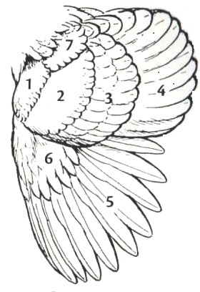**

**WORD BANK**

A. BAR E. FRONT

B. BOW F. PRIMARIES

C. SECONDARY G. WING SHOULDER

D. PRIMARY COVERTS

2024- SMA Chickens PAGE 7

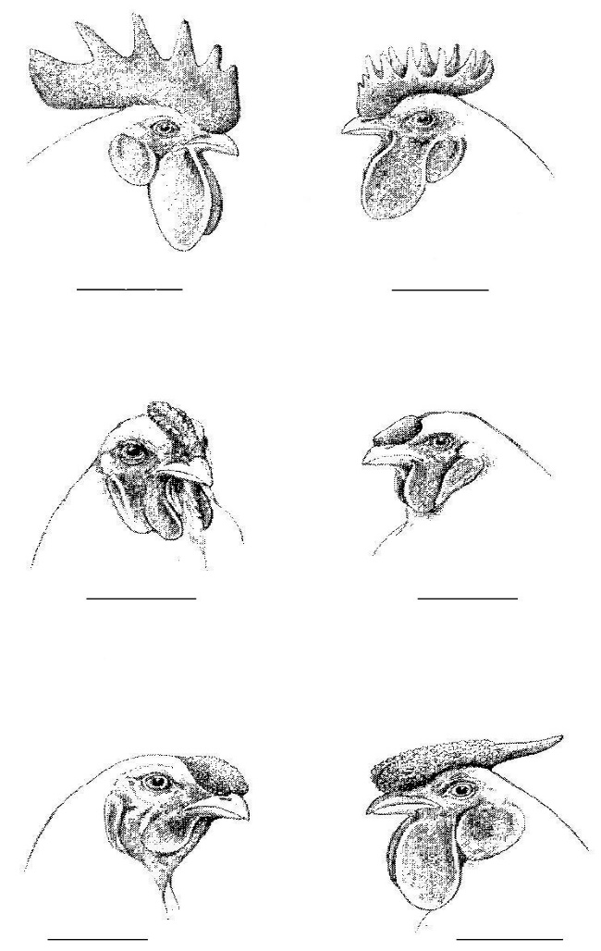

**COMBS**

(write the correct letter of the comb under its picture)

A. ROSE COMB

B. CUSHION COMB

C. PEA COMB

D. SINGLE COMB

E. STRAWBERRY COMB

F. BUTTERCUP COMB

Page 8

SMA Chickens

**HATCH**

**PULLET**

**VENT**

**SCALES**

**COOP**

**HEN**

**ROASTER**

**PUREBRED**

**EMBRYO**

**ROOSTER**

**MOLT**

**SHANK**

**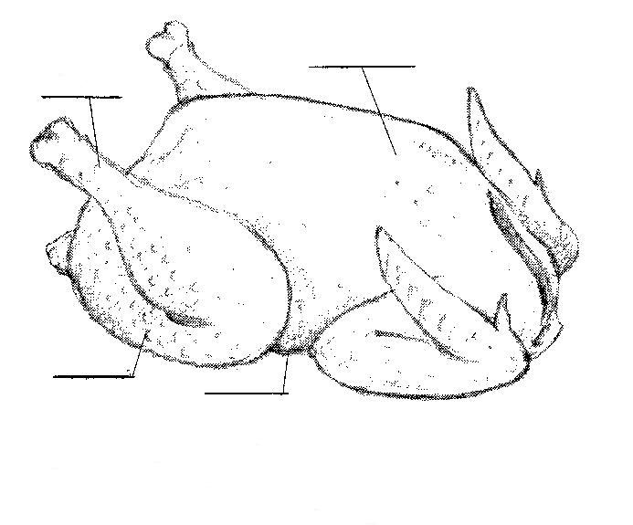**

**BROILER PARTS:**

(write the correct letter of the part on the line it represents on the picture)

A. DRUMSTICK

B. BREAST

C. BACK

D. THIGH

2024- SMA CHICKENS PAGE 8

**PROJECT KNOWLEDGE** (circle the correct answer to the question)

1. What is the document called that is used by the American Poultry Association to

describe purebred breeds of poultry?

A. American Standard of Perfection B. All About Poultry C. Birds of a Feather

2. A starter ration for market chickens should contain at least what percent of

protein?

A. 50% B. 22% C. 78%

3. A term used to describe a serious deformity or a defect which prevents a bird from

receiving an award.

A. Molting B. Parasite C. Disqualification

4. When removing a chicken from a cage, which end of the bird is brought out of

the cage first?

A. Head B. Back C. it does not matter

5. What is a female chicken less than 1 year of age called?

A. Pullet B. Cockerel C. Hen

6. What is a female chicken over one year of age called?

A. Hen B. Pullet C. Cockerel

7. What is a male chicken under one year of age?

A. Pullet B. Hen C. Cockerel

8. The horny formation projecting from the front of the head of chickens forming the

forward mouth-parts.

A. Beak B. Bill C. Bean

9. To be eligible to be shown in a 4-H Poultry Show, chicken and poultry exhibitors

must have a statement or origin or test negative for what disease- at the Oceana

County Fair they test for it upon entry day?

A. Lice B. Coccidiosis C. Pullorum Typhoid

2024- SMA CHICKENS PAGE 9

**PROJECT INFORMATION**

DEFINITIONS:

A. Fleshy protruding part on top of the head of a chicken.

B. A young, meat-type chicken, usually processed before

eight weeks of age.

C. Place between the neck & body where food is temporarily

stored and softened for digestion.

D. Process of removing protruding pinfeathers of poultry.

E. The single body opening in birds

F. A female chicken less than one year old.

G. Skin growing between the toes, also triangular area

of skin in front and between the joints of the wing.

H. A female chicken one year old or older

I. A young, meat type chicken, usually processed at 3 to 4

months of age weighing 4 to 6 pounds.

J. A male chicken more than one year age.

WRITE THE LETTER FROM THE CORRECT DEFINITION IN THE SPACE BELOW:

\_\_\_ CROP

\_\_\_ PULLET

\_\_\_ PINNING

\_\_\_ COMB

\_\_\_ BROILER

\_\_\_ COCK

\_\_\_ ROASTER

\_\_\_ VENT

\_\_\_ WEB

\_\_\_ HEN

**SHOWMANSHIP**

(number the showmanship steps in the correct order)

\_\_\_\_ **Checking the Breast**

\_\_\_\_ **Examining Undercolor**

\_\_\_\_ **Examining Head**

\_\_\_\_ **Examining Wings**

\_\_\_\_ **Posing the Bird**

\_\_\_\_ **Examining Feet and Legs**

**\_\_\_\_ Measuring Depth of Abdomen**

**\_\_\_\_ Showing Width of Body**

**\_\_\_\_ Carrying the Bird**

**\_\_\_\_ Measuring Width of Pubic Bones**

2024- SMA CHICKENS PAGE 10

**WRITE THE CORRESPONDING NUMBER WITH THE PART BELOW**

\_\_\_\_\_ BACK (saddle or cushion) \_\_\_\_\_ EYES \_\_\_\_\_ TAIL

\_\_\_\_\_ BEAK \_\_\_\_\_ HACKLE FEATHERS (male) \_\_\_\_\_ TAIL FEATHERS

NECK FEAHTERS (female)

\_\_\_\_\_ BREAST \_\_\_\_\_ FLIGHT FEATHERS \_\_\_\_\_ THIGH

\_\_\_\_\_ COMB \_\_\_\_\_ HOCK JOINT \_\_\_\_\_ TOES

\_\_\_\_\_ COVERT FEATHERS \_\_\_\_\_ KEEL BONE \_\_\_\_\_ WATTLES

\_\_\_\_\_ EAR \_\_\_\_\_ LEG \_\_\_\_\_ WING

\_\_\_\_\_ EARLOBE \_\_\_\_\_ SHANK

**(Those 9 years old & up complete)**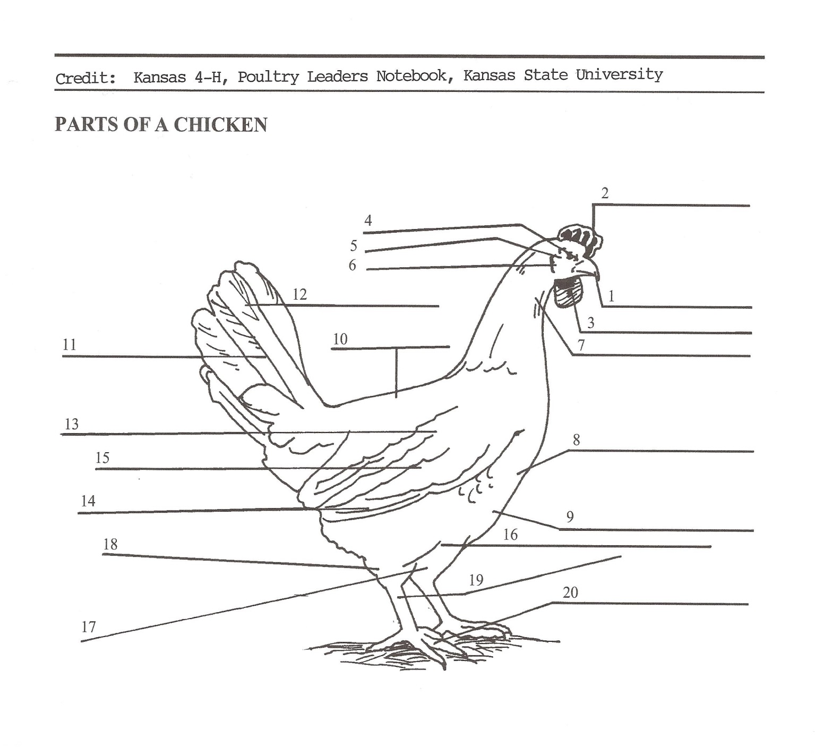

2024- SMA CHICKENS PAGE 11

**(Those ages 8 complete)**

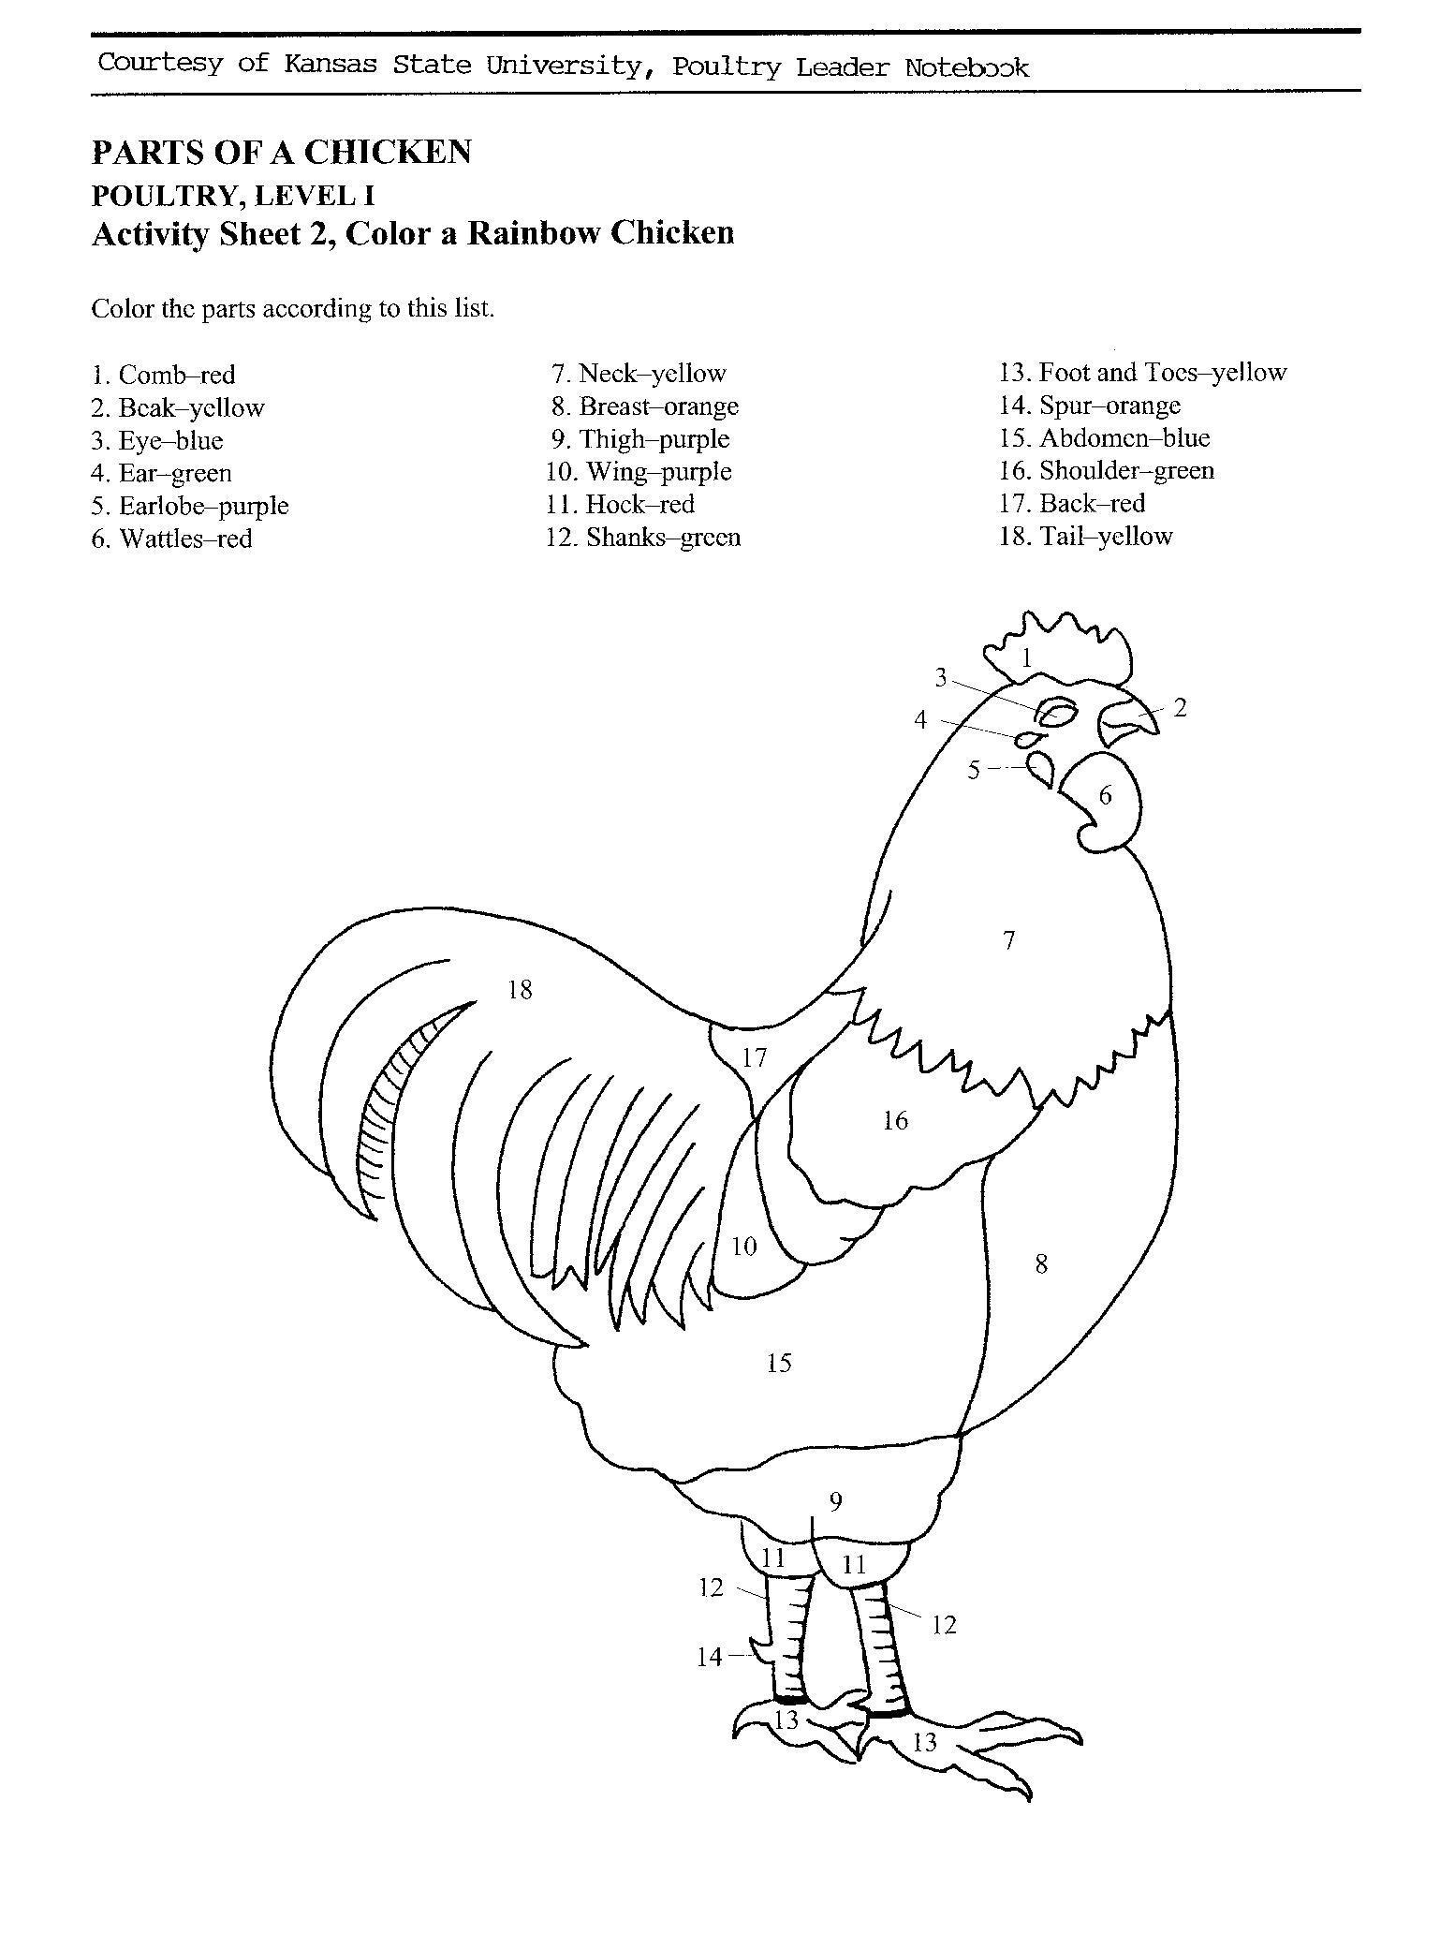

2024- SMA CHICKENS PAGE 12

**PROJECT PROGRESS AND MANAGEMENT REPORT**

1. What part of your project did you enjoy the most? \_\_\_\_\_\_\_\_\_\_\_\_\_\_\_\_\_\_\_\_\_\_\_\_\_\_\_

\_\_\_\_\_\_\_\_\_\_\_\_\_\_\_\_\_\_\_\_\_\_\_\_\_\_\_\_\_\_\_\_\_\_\_\_\_\_\_\_\_\_\_\_\_\_\_\_\_\_\_\_\_\_\_\_\_\_\_\_\_\_\_\_\_\_\_\_\_\_\_\_

\_\_\_\_\_\_\_\_\_\_\_\_\_\_\_\_\_\_\_\_\_\_\_\_\_\_\_\_\_\_\_\_\_\_\_\_\_\_\_\_\_\_\_\_\_\_\_\_\_\_\_\_\_\_\_\_\_\_\_\_\_\_\_\_\_\_\_\_\_\_\_\_

\_\_\_\_\_\_\_\_\_\_\_\_\_\_\_\_\_\_\_\_\_\_\_\_\_\_\_\_\_\_\_\_\_\_\_\_\_\_\_\_\_\_\_\_\_\_\_\_\_\_\_\_\_\_\_\_\_\_\_\_\_\_\_\_\_\_\_\_\_\_\_

\_\_\_\_\_\_\_\_\_\_\_\_\_\_\_\_\_\_\_\_\_\_\_\_\_\_\_\_\_\_\_\_\_\_\_\_\_\_\_\_\_\_\_\_\_\_\_\_\_\_\_\_\_\_\_\_\_\_\_\_\_\_\_\_\_\_\_\_\_\_\_

2. What was the hardest part of your project? \_\_\_\_\_\_\_\_\_\_\_\_\_\_\_\_\_\_\_\_\_\_\_\_\_\_\_\_\_\_\_\_\_\_\_\_\_\_\_

\_\_\_\_\_\_\_\_\_\_\_\_\_\_\_\_\_\_\_\_\_\_\_\_\_\_\_\_\_\_\_\_\_\_\_\_\_\_\_\_\_\_\_\_\_\_\_\_\_\_\_\_\_\_\_\_\_\_\_\_\_\_\_\_\_\_\_\_\_\_\_\_

\_\_\_\_\_\_\_\_\_\_\_\_\_\_\_\_\_\_\_\_\_\_\_\_\_\_\_\_\_\_\_\_\_\_\_\_\_\_\_\_\_\_\_\_\_\_\_\_\_\_\_\_\_\_\_\_\_\_\_\_\_\_\_\_\_\_\_\_\_\_\_\_

\_\_\_\_\_\_\_\_\_\_\_\_\_\_\_\_\_\_\_\_\_\_\_\_\_\_\_\_\_\_\_\_\_\_\_\_\_\_\_\_\_\_\_\_\_\_\_\_\_\_\_\_\_\_\_\_\_\_\_\_\_\_\_\_\_\_\_\_\_\_\_\_

\_\_\_\_\_\_\_\_\_\_\_\_\_\_\_\_\_\_\_\_\_\_\_\_\_\_\_\_\_\_\_\_\_\_\_\_\_\_\_\_\_\_\_\_\_\_\_\_\_\_\_\_\_\_\_\_\_\_\_\_\_\_\_\_\_\_\_\_\_\_\_\_

\_\_\_\_\_\_\_\_\_\_\_\_\_\_\_\_\_\_\_\_\_\_\_\_\_\_\_\_\_\_\_\_\_\_\_\_\_\_\_\_\_\_\_\_\_\_\_\_\_\_\_\_\_\_\_\_\_\_\_\_\_\_\_\_\_\_\_\_\_\_\_\_

3. Would you recommend the breed that you chose for a market project? \_\_\_\_\_\_\_\_\_

Why or why not? \_\_\_\_\_\_\_\_\_\_\_\_\_\_\_\_\_\_\_\_\_\_\_\_\_\_\_\_\_\_\_\_\_\_\_\_\_\_\_\_\_\_\_\_\_\_\_\_\_\_\_\_\_\_

\_\_\_\_\_\_\_\_\_\_\_\_\_\_\_\_\_\_\_\_\_\_\_\_\_\_\_\_\_\_\_\_\_\_\_\_\_\_\_\_\_\_\_\_\_\_\_\_\_\_\_\_\_\_\_\_\_\_\_\_\_\_\_\_\_\_\_\_\_\_\_

\_\_\_\_\_\_\_\_\_\_\_\_\_\_\_\_\_\_\_\_\_\_\_\_\_\_\_\_\_\_\_\_\_\_\_\_\_\_\_\_\_\_\_\_\_\_\_\_\_\_\_\_\_\_\_\_\_\_\_\_\_\_\_\_\_\_\_\_\_\_\_\_

\_\_\_\_\_\_\_\_\_\_\_\_\_\_\_\_\_\_\_\_\_\_\_\_\_\_\_\_\_\_\_\_\_\_\_\_\_\_\_\_\_\_\_\_\_\_\_\_\_\_\_\_\_\_\_\_\_\_\_\_\_\_\_\_\_\_\_\_\_\_\_\_

\_\_\_\_\_\_\_\_\_\_\_\_\_\_\_\_\_\_\_\_\_\_\_\_\_\_\_\_\_\_\_\_\_\_\_\_\_\_\_\_\_\_\_\_\_\_\_\_\_\_\_\_\_\_\_\_\_\_\_\_\_\_\_\_\_\_\_\_\_\_\_\_\_\_\_\_\_\_\_\_\_\_\_\_

2024- SMA CHICKENS PAGE 13

**The 4-H Pledge**

(fill in the blanks)

***I pledge…***

**My \_\_\_\_\_\_\_\_\_\_\_\_\_\_\_\_\_\_\_\_\_\_\_\_\_\_\_\_\_\_ to clearer thinking,**

**My \_\_\_\_\_\_\_\_\_\_\_\_\_\_\_\_\_\_\_\_\_\_\_\_\_\_\_\_\_\_ to greater loyalty,**

**My \_\_\_\_\_\_\_\_\_\_\_\_\_\_\_\_\_\_\_\_\_\_\_\_\_\_\_\_\_\_ to larger service,**

**and My \_\_\_\_\_\_\_\_\_\_\_\_\_\_\_\_\_\_\_\_\_\_\_\_\_\_\_ to better living,**

**For My \_\_\_\_\_\_\_\_\_\_\_\_\_\_\_\_\_\_\_\_\_\_\_\_\_\_, My \_\_\_\_\_\_\_\_\_\_\_\_\_\_\_\_\_\_\_\_\_\_\_\_\_\_\_\_\_\_\_\_\_\_\_\_\_\_\_\_\_\_\_\_\_,**

**My \_\_\_\_\_\_\_\_\_\_\_\_\_\_\_\_\_\_\_\_\_\_\_\_\_\_\_\_\_, and My \_\_\_\_\_\_\_\_\_\_\_\_\_\_\_\_\_\_\_\_\_\_\_\_\_\_\_\_\_\_\_\_\_\_\_\_\_\_\_\_\_.**

**The 4-H MOTTO:** \_\_\_\_\_\_\_\_\_\_\_\_\_\_\_\_\_\_\_\_\_\_\_\_\_\_\_\_\_\_\_\_\_\_\_\_\_\_\_\_\_\_\_\_\_\_\_\_\_\_\_\_\_\_\_\_\_\_\_\_\_\_\_\_\_\_\_.

**FIND, AND CIRCLE, THE FOLLOWING “4-H” WORDS IN THE PUZZLE BELOW**

***Do you practice these Actions?***

|  |  |  |  |  |  |  |  |  |  |  |  |  |
| --- | --- | --- | --- | --- | --- | --- | --- | --- | --- | --- | --- | --- |
| **K** | **S** | **A** | **T** | **C** | **E** | **P** | **S** | **E** | **R** | **H** | **Y** | **H**  **WORD BANK:**  **CARING**  **CHARACTER**  **CITIZENSHIP**  **COMMUNITY**  **GIVING**  **HANDS**  **HEAD**  **HEALTH**  **HEART**  **HONESTY**  **INTEGRITY**  **RESPECT**  **SPORTSMANSHIP**  **TRUST** |
| **T** | **P** | **O** | **R** | **N** | **I** | **S** | **A** | **R** | **A** | **H** | **Z** | **E** |
| **Y** | **O** | **G** | **U** | **Y** | **G** | **M** | **N** | **O** | **I** | **P** | **Q** | **A** |
| **R** | **R** | **L** | **S** | **D** | **N** | **A** | **H** | **Q** | **N** | **H** | **M** | **D** |
| **A** | **T** | **E** | **T** | **L** | **I** | **W** | **E** | **M** | **T** | **P** | **W** | **T** |
| **W** | **S** | **L** | **K** | **M** | **V** | **G** | **A** | **O** | **E** | **G** | **R** | **T** |
| **B** | **M** | **L** | **E** | **W** | **I** | **Y** | **R** | **P** | **G** | **O** | **W** | **Z** |
| **C** | **A** | **R** | **I** | **N** | **G** | **Q** | **T** | **G** | **R** | **Z** | **I** | **P** |
| **E** | **N** | **D** | **E** | **D** | **O** | **D** | **A** | **Z** | **I** | **H** | **P** | **M** |
| **N** | **S** | **Y** | **U** | **B** | **M** | **N** | **Y** | **T** | **T** | **E** | **R** | **S** |
| **C** | **H** | **A** | **R** | **A** | **C** | **T** | **E** | **R** | **Y** | **A** | **P** | **M** |
| **O** | **I** | **W** | **M** | **A** | **N** | **S** | **H** | **O** | **W** | **L** | **E** | **R** |
| **M** | **P** | **G** | **C** | **O** | **M** | **M** | **U** | **N** | **I** | **T** | **Y** | **O** |
| **L** | **E** | **T** | **S** | **G** | **O** | **B** | **L** | **U** | **E** | **H** | **W** | **E** |
| **M** | **H** | **O** | **N** | **E** | **S** | **T** | **Y** | **U** | **M** | **P** | **R** | **E** |
| **G** | **O** | **G** | **R** | **E** | **E** | **N** | **G** | **O** | **W** | **H** | **I** | **T** |
| **E** | **P** | **I** | **H** | **S** | **N** | **E** | **Z** | **I** | **T** | **I** | **C** | **B** |

2024- SMA CHICKENS PAGE 14

**MY 4-H STORY**

(Interesting things that happened to me and my animal this year, challenges, highlights of my year or anything else I would like to share about

my overall 4-H experience)

***POTENTIAL BUYERS NAMES***

As part of your 4-H Market Livestock Project, you must personally contact at least five potential buyers before the Oceana County Fair. You are encouraged to seek two new buyers that have not been asked or submitted before. You also must have at least three different buyers than those of your siblings in the market livestock project. Please confirm with your buyers their accurate mailing address (example: post office box vs. a street address). The information on page 14 must be completed and taken to the Oceana County MSU Extension Office on or before the due date where it will be **copied** and used to send out letters to your potential buyers. This page will remain in your notebooks. This is a Market Livestock Committee rule. Failure to comply will result in not being able to sell your animal in the 4-H Market Livestock Sale. Please have all buyers signatures on **(1)** **one** sheet as copies need to be made at the MSUE office.

Page 15 Date: \_\_\_\_\_\_\_\_\_\_\_\_\_\_\_

2024- SMA Market Chicken Staff: \_\_\_\_\_\_\_\_\_\_\_\_\_\_\_

**SMALL MARKET POTENTIAL BUYER’S LIST**

**CHICKEN PROJECT (AGES 8 & up)**

Name\_\_\_\_\_\_\_\_\_\_\_\_\_\_\_\_\_\_\_\_\_\_\_\_\_\_\_\_\_\_ Club\_\_\_\_\_\_\_\_\_\_\_\_\_\_\_\_\_\_\_\_\_\_\_\_\_

***Please print business names and complete addresses clearly.***

* 1. Contact Name \_\_\_\_\_\_\_\_\_\_\_\_\_\_\_\_\_\_\_\_\_\_\_\_\_\_\_\_\_\_\_\_\_\_\_\_\_\_\_\_\_\_\_\_\_\_\_\_­­\_\_\_\_

Business Name \_\_\_\_\_\_\_\_\_\_\_\_\_\_\_\_\_\_\_\_\_\_\_\_\_\_\_\_\_\_\_\_\_\_\_\_\_\_\_\_\_\_\_\_\_\_\_\_\_\_\_\_

**Mailing** Address \_\_\_\_\_\_\_\_\_\_\_\_\_\_\_\_\_\_\_\_\_\_\_\_\_City\_\_­­­­­­­­\_\_­­­­­­­\_\_\_\_\_\_\_\_\_\_\_\_\_Zip\_\_\_\_\_

Phone \_\_\_\_\_\_\_\_\_\_\_\_\_\_\_\_\_\_\_\_\_\_\_ After Hours Phone\_\_\_\_\_\_\_\_\_\_\_\_\_\_\_\_\_\_\_\_\_\_

Mailing Preference (Please Check One): Email \_\_\_\_ Postal Delivery \_\_\_\_

Email \_\_\_\_\_\_\_\_\_\_\_\_\_\_\_\_\_\_\_\_\_\_\_\_\_\_\_\_\_\_\_\_\_\_\_\_\_\_\_\_\_\_\_\_\_\_\_\_\_\_\_\_\_\_\_\_\_\_\_\_

Signature\_\_\_\_\_\_\_\_\_\_\_\_\_\_\_\_\_\_\_\_\_\_\_\_\_\_\_\_\_\_\_\_\_\_\_\_\_\_\_\_\_\_\_\_\_\_\_\_\_\_\_\_\_\_\_\_\_\_

2. Contact Name \_\_\_\_\_\_\_\_\_\_\_\_\_\_\_\_\_\_\_\_\_\_\_\_\_\_\_\_\_\_\_\_\_\_\_\_\_\_\_\_\_\_\_\_\_\_\_\_­­\_\_\_\_

Business Name \_\_\_\_\_\_\_\_\_\_\_\_\_\_\_\_\_\_\_\_\_\_\_\_\_\_\_\_\_\_\_\_\_\_\_\_\_\_\_\_\_\_\_\_\_\_\_\_\_\_\_\_

**Mailing** Address \_\_\_\_\_\_\_\_\_\_\_\_\_\_\_\_\_\_\_\_\_\_\_\_\_City\_\_­­­­­­­­\_\_­­­­­­­\_\_\_\_\_\_\_\_\_\_\_\_\_Zip\_\_\_\_\_

Phone \_\_\_\_\_\_\_\_\_\_\_\_\_\_\_\_\_\_\_\_\_\_\_ After Hours Phone\_\_\_\_\_\_\_\_\_\_\_\_\_\_\_\_\_\_\_\_\_\_

Mailing Preference (Please Check One): Email \_\_\_\_ Postal Delivery \_\_\_\_

Email \_\_\_\_\_\_\_\_\_\_\_\_\_\_\_\_\_\_\_\_\_\_\_\_\_\_\_\_\_\_\_\_\_\_\_\_\_\_\_\_\_\_\_\_\_\_\_\_\_\_\_\_\_\_\_\_\_\_\_\_

Signature\_\_\_\_\_\_\_\_\_\_\_\_\_\_\_\_\_\_\_\_\_\_\_\_\_\_\_\_\_\_\_\_\_\_\_\_\_\_\_\_\_\_\_\_\_\_\_\_\_\_\_\_\_\_\_\_\_\_

3. Contact Name \_\_\_\_\_\_\_\_\_\_\_\_\_\_\_\_\_\_\_\_\_\_\_\_\_\_\_\_\_\_\_\_\_\_\_\_\_\_\_\_\_\_\_\_\_\_\_\_­­\_\_\_\_

Business Name \_\_\_\_\_\_\_\_\_\_\_\_\_\_\_\_\_\_\_\_\_\_\_\_\_\_\_\_\_\_\_\_\_\_\_\_\_\_\_\_\_\_\_\_\_\_\_\_\_\_\_\_

**Mailing** Address \_\_\_\_\_\_\_\_\_\_\_\_\_\_\_\_\_\_\_\_\_\_\_\_\_City\_\_­­­­­­­­\_\_­­­­­­­\_\_\_\_\_\_\_\_\_\_\_\_\_Zip\_\_\_\_\_

Phone \_\_\_\_\_\_\_\_\_\_\_\_\_\_\_\_\_\_\_\_\_\_\_ After Hours Phone\_\_\_\_\_\_\_\_\_\_\_\_\_\_\_\_\_\_\_\_\_\_

Mailing Preference (Please Check One): Email \_\_\_\_ Postal Delivery \_\_\_\_

Email \_\_\_\_\_\_\_\_\_\_\_\_\_\_\_\_\_\_\_\_\_\_\_\_\_\_\_\_\_\_\_\_\_\_\_\_\_\_\_\_\_\_\_\_\_\_\_\_\_\_\_\_\_\_\_\_\_\_\_\_

Signature\_\_\_\_\_\_\_\_\_\_\_\_\_\_\_\_\_\_\_\_\_\_\_\_\_\_\_\_\_\_\_\_\_\_\_\_\_\_\_\_\_\_\_\_\_\_\_\_\_\_\_\_\_\_\_\_\_\_

(Must be stamped by the MSU Extension Office)

2024- SMA MARKET CHICKENS PAGE 15

**PICTURES OF YOUR PROJECT**

(Please use this page for your project pictures. Add additional pages if you would like. The judges appreciate you labeling the pictures so they know what the picture shows.)

**NON-CLUB POINTS**

**4-H SMALL MARKET ANIMAL ASSOCIATION/JUNIOR MARKET PROJECT**

**ATTENDANCE RECORD**

***(must be filled out by participant before requesting signatures from the office)***

|  |  |  |  |  |
| --- | --- | --- | --- | --- |
| **MEETING NAME** | **LOCATION** | **DATE** | **POINTS** | **SIGNATURE OF LEADER, SUPERINTENDENT OR MSU STAFF** |
| SMAA Annual Meeting | West Michigan Research Station | 10/22/24 | 1 |  |
|  |  |  |  |  |
|  |  |  |  |  |
|  |  |  |  |  |
|  |  |  |  |  |
|  |  |  |  |  |
|  |  |  |  |  |
|  |  |  |  |  |
|  |  |  |  |  |
|  |  |  |  |  |

**Please note:** This form must be included with your record notebook and turned into the weigh master on entry day of the Fair. You need to accumulate **nine (9) points** to be allowed to sell your animal. **Six (6)** of these **nine (9) points** must come from club meetings. **Three (3)** nonclub points from other types of meetings (example: clinics, shows, workshops, fair clean-up and/or county-wide awards).

**CLUB POINTS**

**4-H SMALL MARKET ANIMAL ASSOCIATION/JUNIOR MARKET PROJECT**

**ATTENDANCE RECORD**

|  |  |  |  |  |
| --- | --- | --- | --- | --- |
| **MEETING NAME** | **LOCATION** | **DATE** | **POINTS** | **SIGNATURE OF LEADER** |
|  |  |  |  |  |
|  |  |  |  |  |
|  |  |  |  |  |
|  |  |  |  |  |
|  |  |  |  |  |
|  |  |  |  |  |
|  |  |  |  |  |
|  |  |  |  |  |
|  |  |  |  |  |
|  |  |  |  |  |
|  |  |  |  |  |
|  |  |  |  |  |

**Please note:** This form must be included with your record notebook and turned into the weigh master on entry day of the Fair. You need to accumulate **nine (9) points** to be allowed to sell your animal. **Six (6)** of these **nine (9) points** must come from club meetings. **Three (3)** nonclub points must come from other types of meetings (example: clinics, shows, workshops, fair clean-up and/or county-wide awards).